Project Design Phase-II
Data Flow Diagram & User Stories

Date | 21 February 2026
Team ID | LTVIP2026TMIDS77557
Project Name | Calculating Family Expenses using Service Now
Maximum Marks | 4 Marks

Data Flow Diagrams:
A Data Flow Diagram (DFD) is a traditional visual representation of the information flows within a system. A neat and clear DFD can depict the right amount of the system requirement graphically. It shows how data enters and leaves the system, what changes the information, and where data is stored.
Data Flow Diagrams:
Level-0 Data Flow Diagram
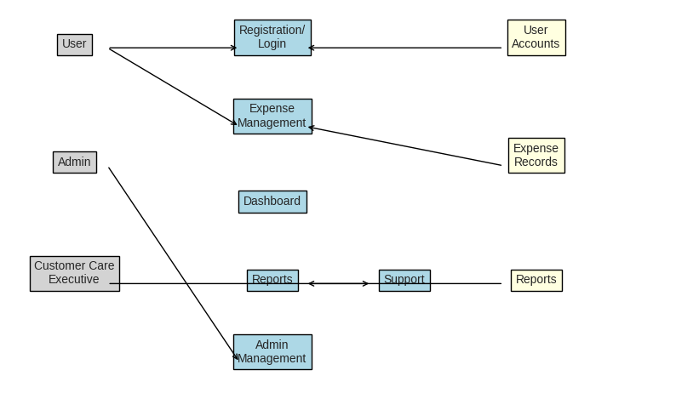

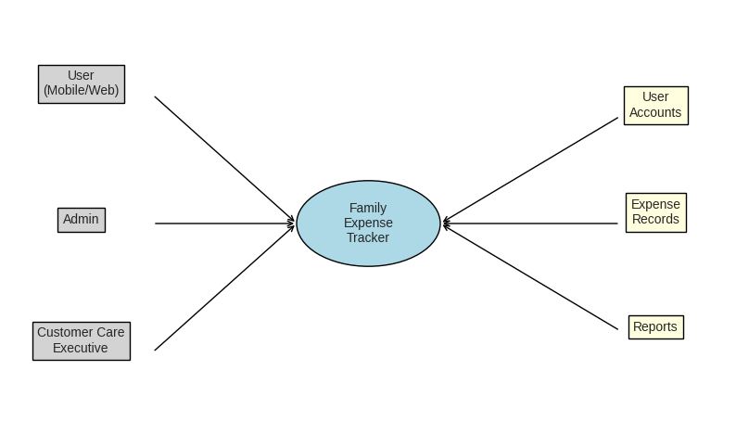
Level-1 Data Flow Diagram

Level-1 Data Flow Diagram

User Stories:

User Type | Functional Requirement | User Story Number | User Story | Acceptance Criteria | Priority | Release
Customer (Mobile/Web User) | Registration | USN-1 | As a user, I can register with email/password | Account created, dashboard accessible | High | Sprint-1
 |  | USN-2 | As a user, I receive confirmation email | Email received, confirm link works | High | Sprint-1
 |  | USN-3 | As a user, I can register via Facebook | Login successful via Facebook | Low | Sprint-2
 |  | USN-4 | As a user, I can register via Gmail | Login successful via Gmail | Medium | Sprint-1
 | Login | USN-5 | As a user, I can log in with email/password | Login successful, dashboard visible | High | Sprint-1
 | Expense Management | USN-6 | As a user, I can add daily expenses | Expense saved & visible in dashboard | High | Sprint-1
 | Dashboard | USN-7 | As a user, I can view expense summary | Dashboard shows charts/tables | High | Sprint-2
 | Reports | USN-8 | As a user, I can generate monthly reports | Report downloadable as PDF/Excel | Medium | Sprint-3
Administrator | User Management | USN-9 | As an admin, I can manage user accounts | Admin can add/remove users | Medium | Sprint-2
Customer Care Executive | Support | USN-10 | As an executive, I can respond to user queries | Ticket system updates status | Low | Sprint-3

